User Manual
Of Digital Set Top Box

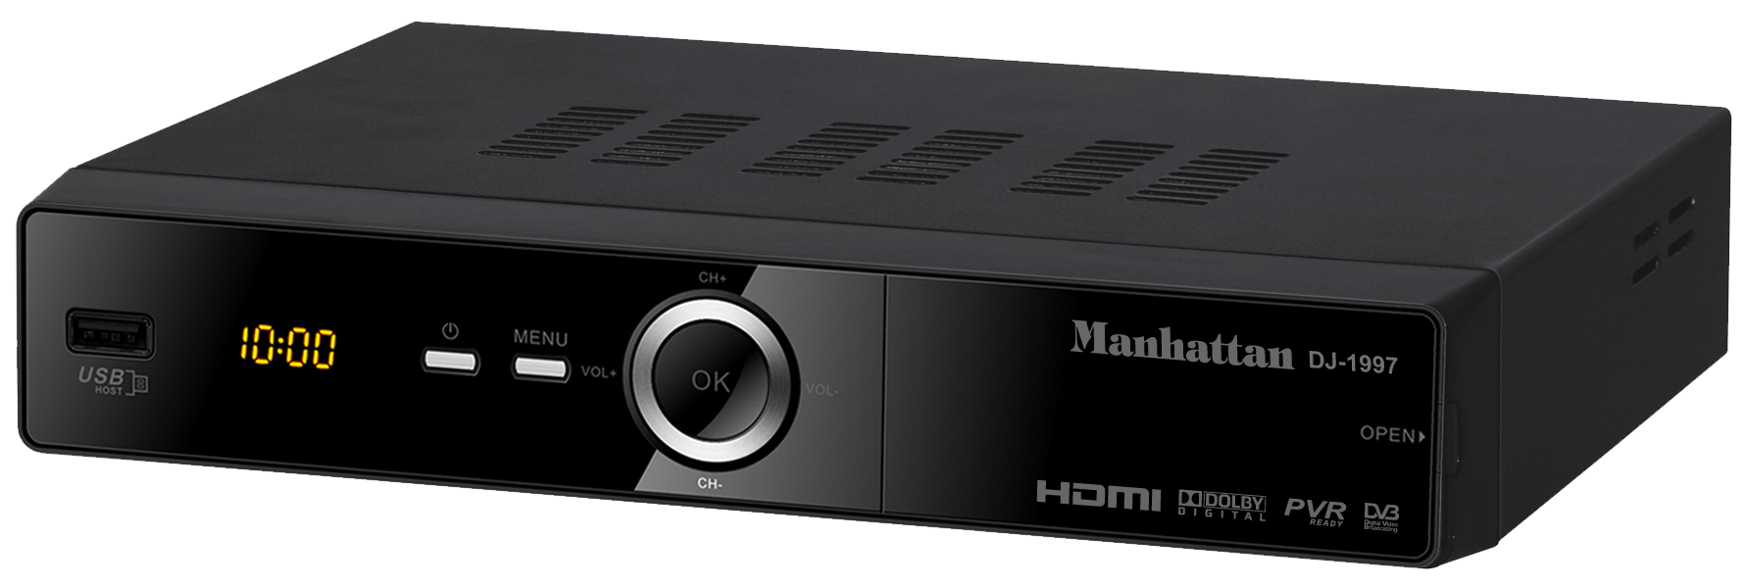

Manhattan DJ-1997

Please read this User Manual carefully to ensure proper use of this product and keep this manual for future reference.

Table of Contents

Important Safety Instructions……..........................................................................1

Front and Rear Panel Illustration........................................................................2

Remote Controller.............................................................................................3

Connections.....................................................................................................5

Quick Installation.................................................................................................6

DTV Operation....................................................................................................9

Multimedia......................................................................................................19

DVR................................................................................................................21

Troubleshooting ...........................................................................................24

Specifications..................................................................................................25

Important Safety Instructions

*Warning: To reduce the risk of electric shock, do not remove the cover or back. There are no user-serviceable parts inside. Refer servicing to qualified personnel.
*Warning: To prevent fire or electric shock hazard, do not expose the unit to rain or moisture.
*Do not expose the Adaptor and Set top box to water (dripping or splashing) and no objects filled with liquids, such as vases, should be placed on the unit.
*Keep the Set top box away from direct sunlight and heat source such as radiators or stoves.
*Do not block the ventilation openings. Slots and openings on the unit are provided for ventilation. The openings should never be blocked by placing your Set top box on a cushion, sofa or other similar surface.
*Do not place the Set top box on unstable cart, stand, tripod, bracket or table. The unit may fall, resulting in possible damage or injury.
*Only use the AC adapter included with Set top box. Using any other adapter will void your warranty.
*Unplug the power from the outlet when the unit is not in use.
*Attention should be drawn to the environmental aspects of battery disposal.
*WARNING: The battery (battery or batteries or battery pack) shall not be exposed to excessive heat such as sunshine, fire or the like.
*WARNING: Excessive sound pressure from earphones or headphones can cause hearing loss.
*WARNING: Only use attachments/accessories specified provided by the manufacturer, the Set top box is supplied by AC adapter, the AC adapter is used as disconnect device, the disconnect device shall remain readily operable.
Caution: Danger of explosion if battery is incorrectly replaced, replaced only with the same or equivalent type (Lithium battery)
The symbol indicates that dangerous voltages constituting a risk of electric shock are present within this unit.

The symbol indicates that there are important operating and maintenance instructions in the literature accompanying this unit.

The USB memory stick should be plugged in the unit directly. USB extension cable should not be used to avoid failing of data transferring and interference caused.
This marking indicates that this product should not be disposed with other household wastes throughout the EU. To prevent possible harm to the environment or human health from uncontrolled waste disposal, recycle it responsibly to promote the sustainable reuse of material resources.

To return your used device, please use the return and collection systems or contact the retailer where the product was purchased.
They can take this product for environmental safe recycling.

1

Front and Rear Panel Illustration

1. Front Panel

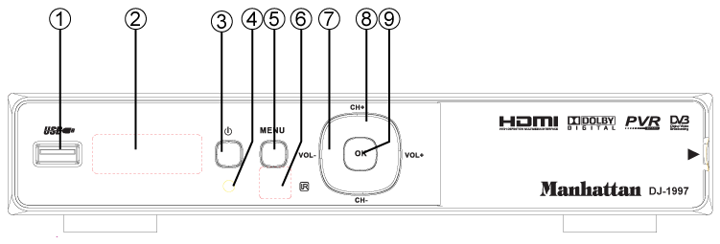

1. USB JACK: Used to connect to an external USB 2.0 device.
2. LED DISPLAY: Used to display the time or channel information.
3. STANDBY: Used to switch the set top box to on or standby.
4. STANDBY INDICATOR: Used to visually show power state of the STB.
5. MENU: Turns on main menu.
6. REMOTE CONTROL SENSOR: Used to receive the signal from the remote control.
7. VOL +/-: Used to increase/decrease the volume without using the remote control.
8. CH +/-: Selects the next/previous Channel without using the remote control.
9. OK: Confirms an entry or selection.

2. Rear Panel

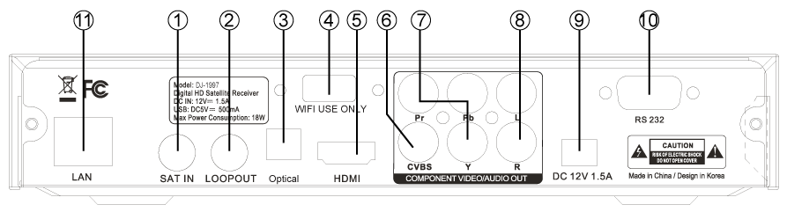

1. LNB IN: This socket connects the LNB to receive the signal.
2. LOOP OUT: This socket will bypass the RF signal to either your TV or another video system.
3. SPDIF: This socket connects to an optical socket on your surround sound system.
4. USB JACK: Used to connect to an external Wi-Fi Antenna for Internet use.
5. HDMI OUT: This socket connects to HDMI in device.
6. CVBS: This socket outputs composite video signal.
7. Y/Pb/Pr: These sockets connect to your TV component input terminals.
8. AUDIO L/R: This socket outputs analog audio L/R adapter.
9. DC IN 12V: This is used to connect the 12V DC adapter.
10. RS232: Connect to serial port of PC for software update.
11. LAN: Connect to RJ45 cable for internet connection

2

Remote Controller
.
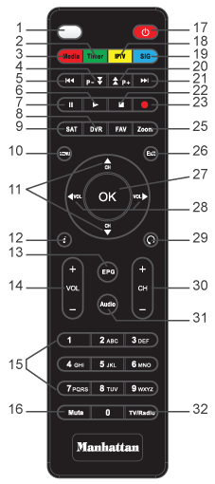

1. LED display lights to verify remote operation
2. Enter the Manual Timer Setting menu
3. Display Media Player for Videos / Photos / Music
4. Page Down in a List and DVR Scan Rewind
5. Skip Rewind
6. Play DVR / Media
7. Freeze Video or Pause DVR / Media
8. Display DVR Recordings List
9. Display Satellite List
10. Display the Main Menu Screens
11. Change Channel or Menu Navigation Up / Down
12. Display Channel Banner, 2x for Program EPG,
3x for Service Information
13. Display Electronic Program Guide (if provided)
14. Increase / Decrease Volume
15. Numeric / Alpha Keys for direct Channel Chang
-e and Menu Setting
16. Mute or Enable Muted Audio
17. Select Standby or Operation Mode
18. Move to open IPTV Channel
19. Display a Full Screen Signal Meter
20. Page Up in a List and DVR Scan Forward
21. Skip Forward
22. Stop DVR Play or Record / Stop Media Playback
23. Start DVR Manual Record
24. Select the Favorite List Mode
25. Magnify a Portion of the Screen
26. Exit Screens or Functions
27. Display the Channel List or Accept a Menu Item
28. Increase / Decrease Volume or Menu Navigation
Left / Right
29. Return to Previous Channel
30. Change Channel Up / Down
31. Select Alternative Language / Audio Mode / Sound Track
32. Select to View TV or Listen to Radio Channels

3

Remote Controller
Installing the Batteries
Remove the battery cover from the remote control and put 2xAAA size batteries inside the compartment.
The diagram inside the battery compartment shows the correct way to install the batteries.
1. Open the cover
2. Install batteries
3. Close the cover

Using the Remote Control
To use the remote control, point it towards the front of the digital set top box.The remote control has a range of up to 7 meters from the set top box at an angle of up to 60 degrees. The remote control will not operate if its path is blocked.

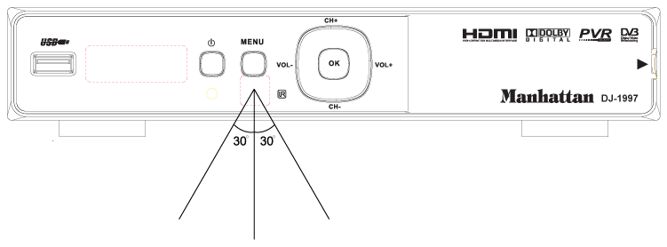

Note:
Sunlight or very bright light will decrease the sensitivity of the remote control.

4

Connections

Caution:
Make sure to check the voltage specification of the wall outlet is the same rating with the receiver. To prevent the risk of electric shock, do not open the cover or the back
of the receiver.

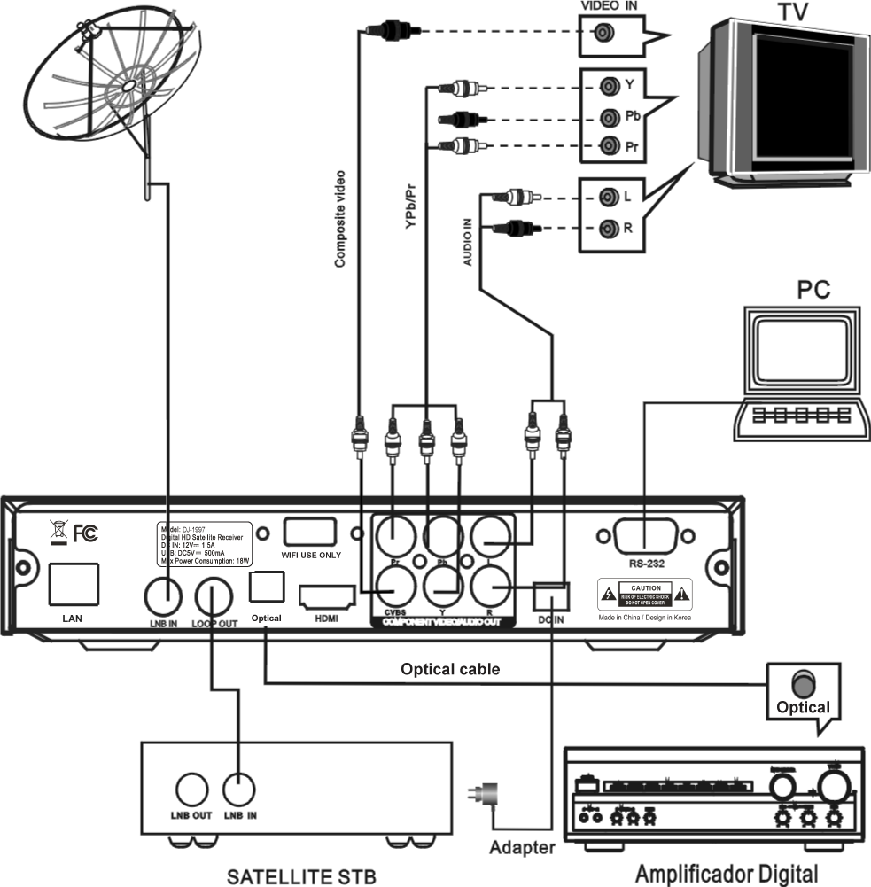

Note:
When connecting the receiver to other equipment, e.g., TV, VCR and amplifier, make sure to refer to relevant user manual for instruction. Also, make sure you disconnect all the equipment from the mains supply before the connection.

5

Quick Installation

(1) Unplug the set-top box and television.
(2) Connect the antenna to the RF input of the box with coaxial cable.
(3) Connect the audio out port and video out port on the box to the audio in port and video in port on the television respectively using audio/video cables.
(4) Plug and power on the set-top box and television.

Program Scanning
Satellite Setting
In Installation page, select Satellite Setting and press <OK>.
In the page displayed, you can use the <Left/Right> buttons to change the mode, and set the proper satellite parameters.
(1) Press <Up/Down> to select among satellites.
(2) Press <OK> to confirm the selection of the currently focused satellite.
(3) Press <Right> to go to the satellite parameter setting page.
(4) Press <Red> to go into the SAT/TP Manager page.
(5) Press <Green> to go into the Automatic SAT Scan page.
(6) Press <Yellow>Goto position when motor is Diseqc1.2/USALS.

Note: Only the satellite checked in the setup manual can be scanned. You cannot scan an unchecked sat.

Notice: Motor setting: Switch focus to motor items, switch to Disqc1.2/USALS , press <OK> enter Motor setting Page, after set Disqc1.2/USALS ,you must Press Store save it .Unicable setting : As Motor setting.
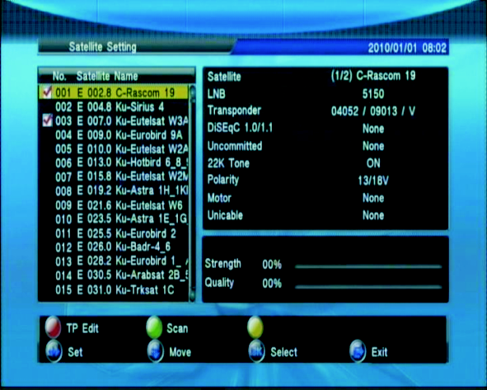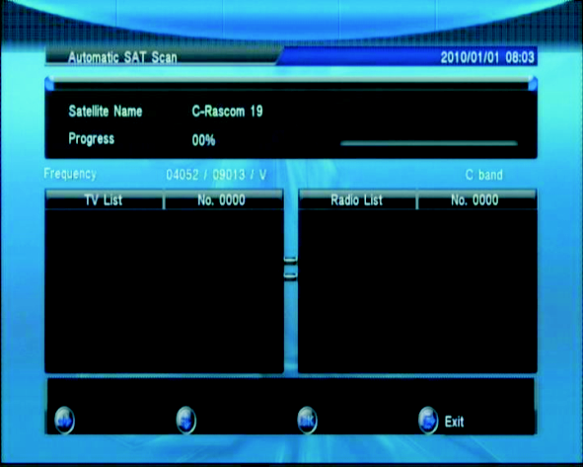

6

Channel Scanning
1. Automatic Sat Scan
With the Auto SAT Scan function, you can perform TV-channel scanning on one or more satellites. Before proceeding, you need to make sure all the parameters for satellite connections are set correctly. For the satellite parameter setting for a dedicated connection mode.

(1)After the satellite parameter setting, press <Green>. The Auto Sat Scan page will appear.
(2)Press <Up/Down> buttons to select the Program to set the type of the program you want to scan. The program type has two options, Free only and All.
(3)Press <Up/Down> to select the NIT mode. Search and add the TPs by referencing to the satellite NIT Table, and scan for the program channels from all the TPs.
(4)If your intention is to scan one specific satellite, you need to specify it first.
(5)Press <Up/Down> buttons to select your Scan Mode. The options here include:
Default TP Mode: Scan only the channels from preset Tps, and will not try to add a new TP.
One TP Mode: Search and add one TP by referencing to the satellite NIT Table, and scan for the program channels from the TP.
Blind Mode: Automatically search Tps in the IF range, and scan the TV-channels available form the Tps found.
(6)Press <Up/Down> to confirm your Scan Select. In here, you can choose to apply the scan on one or more satellites to scan.
* only the satellites checked in the setup manual can be scanned. You can't scan an unchecked satellites.
(7)Press <Green> button. Start scan

2. Manual Scan
This feature provides you a way to scan channels from the TPs specified by your own customized settings such as Frequency, Symbol Rate, Polarity, NIT, and Program. Before proceeding, you need to make sure all the parameters for
satellite connections are set correctly. For the parameter setting for a dedicated connection mode.
(1)After the parameter setting, press <OK>. The Manual Scan page will be open.
(2)Press <OK>, and select your desired satellite from the satellite list.
(3)Using the <0~9> keys to set your desired Frequency and symbol rate, range from 0 to 65535.
(4)Using the <Left/ Right> buttons to set Polarity, NIT, Program type.
(5)After finishing above-mentioned settings, Press <Green>. Then, the Manual Scan will start.

7

3. Satellite/TP Management
This manager provides features including add, delete, and edit for you to manage your satellites and TPs thereof.
(1)Move the focus to your desired satellite name and then press the color key to open the satellite manager page.
(2)Press < Red> to start editing the selected satellite by using the < Left/ Right>
buttons to set the options.
(3)Press < Yellow> to add new satellite, and use the < Left/ Right> buttons to set the options.

(4)Press < Blue> to delete the selected satellite.
(5)Move the focus to your desired TP, and press the color key to go into the TP Manager page.
(6)Press < Red> to start editing the selected TP by using the < Left/ Right>
buttons to set the options
(7)Press < Yellow> to add new TP, and use the < Left/ Right> buttons to set the options.
(8)Press < Blue> to delete the selected TP.
(9)Press < Green> to bring out the Automatic SAT Scan page.

8

DTV Operation
Main menu
When your set-top box is power on, a press on the Menu button will bring out the Main Menu. In this menu, press <Exit> button to switch into the TV's Normal Play mode. Here, you can further select the operation mode for your set-top box using the
<TV/Radio> button. For example, if you select TV or Radio, the box will go into Normal Play mode and start playing your desired program. And this is only one of the many features available here.

Press < Menu> button to enter into the Main Menu page.

Channel
In the Channel menu, you can edit the channels that you want to play in the Normal Play mode. The functions available here include TV channel editor, Radio channel editor, and EPG.

TV/Radio Channel Editor
(1)Press <Menu> to open the Main menu.
(2)Select the item Channel using <Left/Right> buttons.
(3)Select TV/Radio channel editor, the TV/ Radio List will appear and allows you to manage your desired programs.
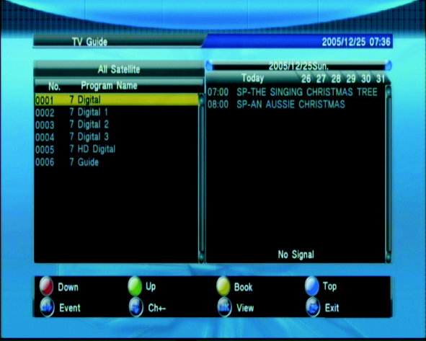
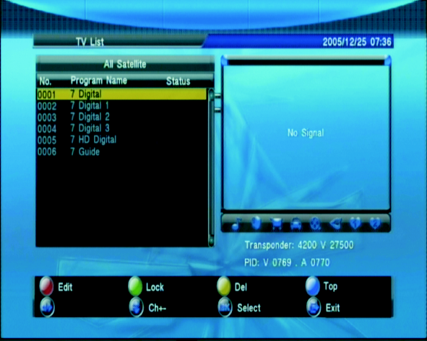

Press <Favorite> buttons to set/cancel TV/Radio channel favorite type Press
<Red/Green/Yellow/Blue> buttons to select the TV List option Edit/Lock/Del/Top.

1. Favorite: you can manage and add your favorite channel into eight preset groups, which are simply numbered 1 - 8.
(1)Press < Favorite> to bring out the favorites list.
(2)Press < Up/Down > to select your desired channel.
(3)Press < Left/ Right> buttons to select your desired favorite list.
(4)Press < OK> to add the channel to the selected list.
(5)Press < Exit> to save the list.
(6)Press < OK> to confirm the save, or < Exit> to cancel it.
If you want to add more channel to favorite lists, please repeat steps (4)~(6).

2. Edit
(1)Press < Red> to Edit TV/Radio channel name.
(2)Press < Green> to move TV/Radio channel position in the list
(3)Press < Yellow> to sort TV/Radio channel in the list
(4)Press < Green> to set /cancel TV/Radio list skip status, then you cannot find in the list except skip list.

9

3.Lock: Press <Green> to set/cancel tv/radio list lock status.
4.Del:Press <Yellow> to set/cancel tv/radio list del status ,when you exit TV/Radio list edit , the result will saved.
5.Top: Press <Blue> to set/cancel tv/radio list lock status.

Guide
The Guide page, also known as EPG (Electronic Program Guide), provides you
not only the program guide and program information but also the feature for you to make an appointment to watch and schedule the program recording.
(1)In the Channel page, select EPG using the < Left/ Right> buttons.
(2)Press < OK> , and the TV Guide page will appear.
In Normal Play mode, you can press <EPG> to enter into the guide page directly.

1.Service List: you can select channels to view the EPG information.
Notice:
(1) If the channel you select provides no EPG information, then a message
No EPG Event will appear.

(2) With < Red/Blue> buttons you can scroll the pages up and down.
(3) With < Yellow> button you can directly enter into the Advance Timer setup page. For details about the timer setting.
2. Event List:
It will show the events scheduled for the channel listed in the Guide.
(1) Press <Left/Right> to move the focus from Service List to Event list.
(2) Press <Left/Right> buttons to select the event date you want to check .
(3) Press <Up/Down/Page up/Page Down> to scroll through the Event List to check your desired event.

3. Event Book:
You can schedule your desired Event there for watching or recording it.
(1) Select your desired Event.
(2) Press< Yellow> button to enter into Advance Timer page to schedule the Event.

4. Event Detail:
Select the event you would like more details on.
(1)Select the event that you want to view.
(2)Press <OK> to show the details about the event.
(3)Press<Page up/Page Down> to scroll the details.
(4)Press<Yellow> button to enter into Advance Timer page to schedule the Event. For details about the Advance Timer, Please see Advance Timer Section on Page 13.

Multimedia
In Multimedia menu, you can play your multimedia files, for more details, please refer to the sections regarding MM and DVR.

Network Setting
The unit can support Wired Network and Wireless Network, and the Wireless
Network is inserted inside.

10

(1)Wired Network
If you want to use Wired Network, you first enter main menu to set Network interface in Wired Network, and there are two modes.
[AUTO], it will automatically get IP address to connect.
[Manual], you need manually input IP address, Net Mask address, Gateway address and DNS address.

(2)Wireless Network
If you want to use Wireless Network, you first enter main menu to set Network interface in Wireless Network, and select Wireless Network item and press OK button to get hot point. If you can get any hot point, please try to press RED button to refresh it. You select one hot point and press BLUE button to connect it, this connect is ok when the true displays in this item.

System Setting
In System Setting menu, you can change the system parameters and configure your set-top box.
(1) Press < Menu> button to open the main menu.
(2) Select System Setting using < Left/Right> buttons.
(3) Press <Up/Down>to select your desired submenu, where the options are Language, OSD Style, Time, TV Setup, Adv Timer, Parental control, Update& Backup, and Factory setting.
(4) Press < OK> to enter into the selected submenu.

Notice:
(1) In the System Setting menu, you can use <Up/Down> buttons to switch between the System Setting submenus.
(2)The system setting submenus available here includes: Language/OSD Style/Time/ TV Setup/ADV Timer/Parental control, Update & Backup and Factory setting.

Language
In Language menu, you can switch OSD language/audio language (TV program must supports multi audio language)/subtitle language (TV program support multi subtitle language).

OSD Style
You can set the OSD display options, including the transparency and banner display time.

Time
1. Time Zone: you can set your time zone. However, the time will be displayed correctly only when connected to the Network time server (In order to have the correct time you need to connect the LAN cable; to get internet connection).

11

2. Set Date: If the internet connection is not available, you can set the system date here.
(1) The setting range is from 1970/01/01 to 2038/03/31. Any date before 1970/01/01
will be set to 1970/01/01, and any date after 2038/03/31 will be set to 2038/03/31.
(2) Any change made here will be immediately reflected to the system.

3. Set Time: If the internet connection is not available, You can set the system time here .
(1)To change AM/PM, cursor over the AM/PM sign and press the OK button.
(2)Any change made here will be immediately reflected to the system setting.

TV Setup
In TV Setup submenu, you can select the TV output mode.

1.TV Format: you can select the TV format for your TV shows. This feature supports
4 :3LB, 4 :3PS, 1 6:9LB, and 1 6:9FIT.

2. TV Mode: you can select the TV mode for your TV shows from the options, including PA L and NTSC. However, you have to make sure your TV supports the mode you select.
(1) Any change made here will be immediately reflected to the output mode.
(2) After any change made here, the TV Resolution will automatically change to the respective default value, 576i for PA L and 480i for NTSC.
(3)The default setting of TV Mode is PA L.
(4) Currently this option is fixed to PAL and cannot be changed.

3. This feature supports formats such as SCART (CVBS), SCART (RGB), and H DMI.
(2) Before you connect the video outputs of your set-top box to the video inputs of your TV, please make sure the inputs and outputs are consistent with your setting made here.
(3) The default setting of Video Output is Scart ( CVBS) if there is no HDMI connection between your box and TV; otherwise, the default setting i s H DMI.
(4) If there i s n o HDMI connection between y our b ox and TV, you will not be allowed to set the output format to HDMI.
(5) When they co-exists a HDMI and a SCART connection, if your box detected
that the TV is set to HDMI mode, it will switch to HDMI output mode automatically.
(6) If t his feature is set to SCART (CVBS), or SCART (RGB), the TV Resolution
will automatically change to the respective default value, 576i f or PAL and 480i f or
NTSC.
(7) Any change made here will take at least one second to be applied.
4. TV Resolution: you can set the resolution for your video output.
(1) If this feature is set to SCART (CVBS), or SCART (RGB), the TV Resolution cannot be changed.

12

(2) When this feature is set to HDMI, the available resolution options for
PA L mode are 720p_50Hz, 1080i_50Hz,1080p_50Hz, and AUTO, and for NTSC mode are 720p_60Hz, 1080i_60Hz, 1080p_60Hz, and AUTO, while you are not allowed to switch to the resolutions not supported by your T V.
(3) If there is HDMI connection between your box and TV, the default setting of TV Resolution is AUTO; otherwise, the default setting is 576i.
(4) Any change made here will take at least one second to be effective.

5. Digital Audio Output: you can set the format for your digital audio output.
(1) The options available here are LPCM and RAW.
(2) The default Digital Audio Output is LPCM.

6. Power On at: By setting this option to TV or Menu, you can set your box to show TV or Main menu the next time it turns on.

7. Auto Switch off: you can set the time for how long your set-top box will wait for the signal from the remote controller before it enters into sleep mode automatically. The timer will start counting at once when there is no remote controller operation. When the timer expires, the set-top box will go in to sleep mode.

8. TV Brightness: you can set the brightness of the display, where the greater the value the higher the brightness.

9. TV Contrast: you can set the contrast of the display, where the greater the value the higher the contrast.

10.TV Saturation: you can set the saturation of the display, where the greater the value the higher the saturation .

Advance Timer
With this feature you can schedule up to 10 events. The event timers can turn on or record a specific channel for the amount of time you set.

1. Add Event: you can schedule an event here.
2. Edit Event: you can edit the existing events here.
3. Delete Event: you can delete an existing event.
(1)Press < Red> button to delete the event.
(2)Press<OK> button to confirm your delete operation.
After an event is deleted successfully, the other events in the list will be sorted automatically by their start time.

Notice:
(1)When your new event conflicts with an existing event in some way, for example,
a time-range overlap, a message box will appear to notify such confliction and the attempt fails.
(2)After your new event is added successfully, the events in the list will be sorted automatically by their start time, earliest first.
(3)When manually entering a channel number, if the number exceeds maximum channel number available here, the system will automatically adjust the number to a proper one.

13

(4)There are two advance timer modes, Schedule and Recorder. Schedule: as soon as the scheduled start time is reached, your set-top box will switch to Normal Play mode, and start playing the scheduled program. If Recorder: if the scheduled program and the program currently playing are received from the same TP, then the recording will start in background.

4. Activate Event
When it is time for an event to start, a schedule timer will expire, and it will activate the relative event.
(1) Switch between the channels in the same TP. If the channels you switch to the one not in the same TP, it will trigger a message prompting if you want to stop the event.
(2)When the event reaches its end time, it will notify you by triggering an event end message.

Notice:
(1)If your set-top box activates an event while it is in the sleep mode, it will go back to the sleep mode after the event ends.
(2)For an event that is set to “once” mode, it will be deleted from the event list after
it ends. For an event that is set to other modes (Daily/Weekly/Weekend-day/
Weekday), its start time will be set to the next date automatically after the completion of current execution. To stop the event, you are required to delete it from the list manually.
(3)When an event of Recording reaches its start time, a no-device message will be triggered with the event being suspended if the system detects no storage device. You can restore the recording event by plugging a storage device in the box before the end time.

Parental control
In Parental Control submenu, you can set the channel and censorship locks, and change your password (initial value:0000) here.
1. Menu Lock: you can set the menu lock on/off.
When this feature is set to ON, you will be required to enter password when you are trying to enter into the submenus in Setup page, such as Installation, Channel, Multimedia, System Setting, and Others.

2. Channel Lock
Channel Lock: you can set the channel lock ON/OFF.
(1)When it is set to ON, you are required to enter your password when you are trying to open the TV list and Radio List.
(2)When it is set to ON, you are required to enter your password when you are
trying to enter into the setup submenus such as Installation, Channel, Multimedia, System Setting, and Others.

3. Censorship Lock:
You can set the rating for the censorship lock feature.
(1) The program comes with its rating info. If the rating is higher than the one you made here, your TV screen will only show a Censorship Lock message, instead of playing the program.
(2) If this feature is set to Total Block, all the programs will be blocked. In this case, your TV screen will only show a message notifying the censorship lock has blocked the program.

14

4. Change Password
You can change your password here.
After restoring to factory default, this feature will be set to NO, and the password will be 0000 again.

Update& Backup
In the Update&Backup submenu, you can choose to update your set-top box software applications. Or read software and database from set top box
- USB Upgrade
You can upgrade your set-top box software applications using USB devices.
(1) Enter into the upgrade page.
(2) Select the directory.
(3) Move the focus to the file list.
(4) Select your upgrade file (*.ssu).
(5) Press < OK> button to start the upgrade.
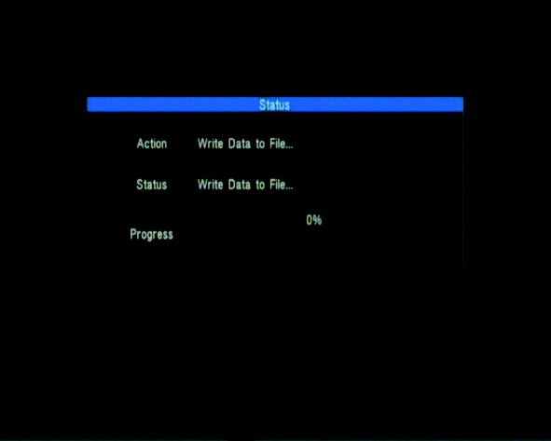
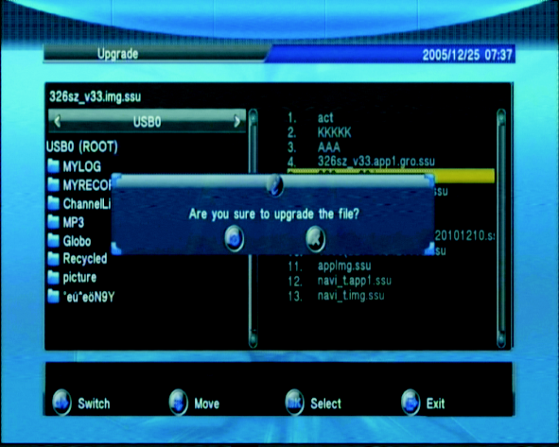

2. Image Backup: you can backup your set-top box software applications to your
USB device.
(1)Enter into the backup page.
(2)Select the content you want to backup.
(3)Select the backup path
(4)Press < OK> button to confirm your selection
(5)Press <Left/Right> buttons to move the focus to the file list.
(6)Press <OK> button to start your backup.
Factory Setting
You can restore the settings to default factory value for your set-top box.
All the changes have been made will be replaced by their default values, and the channel data will be clear.
Notice:
(1) After restoring to default factory value, the reservation information stored in the
Advance Timer feature will all be deleted.
(2) All channel information stored in the system will be deleted.
(3) All the changes you have made to the setting will restore back to default.
(4) The program type and program number, which construct the program information, will show TV and 0 respectively.

Factory DB Setting(On Channel Menu)
You can restore the default Satellite, TP and channel lists for your set-top box.
All the settings will be replaced by their default values.
The set-top box will be restart after this process.
Others
You can access here to some auxiliary functions, including YouTube.
YouTube: you can watch YouTube video when you connect internet.

15

Playback
You can select to watch TV or listen to the radio in Normal Play mode. Since watching TV and listening to the radio in Normal Play mode are identical in their ways of operating, in this section we will focus on how to watch TV.
In Normal Play mode, Press <TV/Radio> to switch between TV and Radio programs.

Program Info
The Banner provides the program info including the channel number, program name, favorite list, date and time, previous/next event, lock status, scramble status, subtitle, and teletext.
(1)Press < Info> to bring out the banner.
(2)Press < Info> again to show the Event Detail.
(3)Press < Info> again to show the signal information.
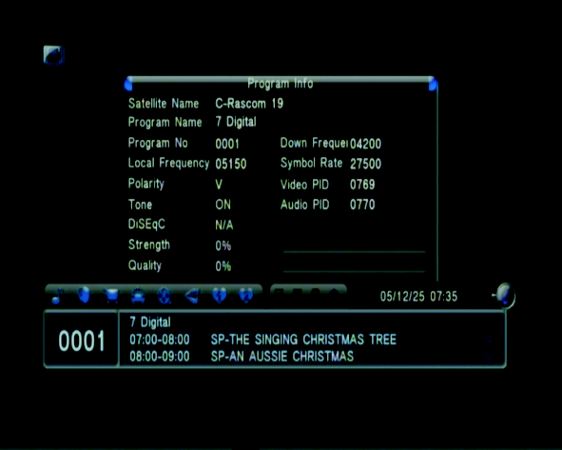
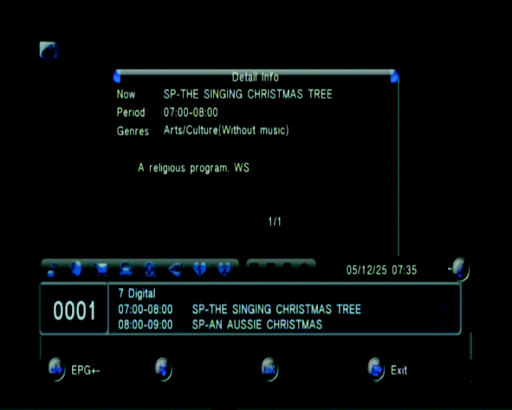

Switch Channel
You can press <Up/Down/Ch+/Ch->or enter a channel number to switch channel.

Notice:
(1)If the channel number you enter does not exist, your set-top box will ignore it.
(2)When a recording event is proceeding, you can switch channel only with
< Ch.+/Ch.-/Up/Down >but not < 0~9/OK>. However, if you switch to a channel in
a different TP, the recording event will abruptly abort.

Recall
You can press Recall button to switch directly back to the channel you previously watched.

Notice:
(1) The channel you switch back to with <Recall> button is the one you previously watched.
(2) This Recall function will not apply between a TV channel and radio channel.
(3) If you stay on a channel without any switching operation previously, there will be no response when you press the return button.

Ok list
In the Normal Play mode. Press <OK>button, you can enter ok list. Through this list, you can check, switch and search among programs.
(1) Press <Green> and a software keyboard will appear.
(2) Press <Up/Down/Left/Right/OK> to enter the channel name.
(3) Press <Exit> to complete the name entering, and the screen will go back to the
List page.

16

(4) Press <Left/Right> to select the search mode, Search Forward or Search
Backwards.
(5) Press<OK>to start your search.
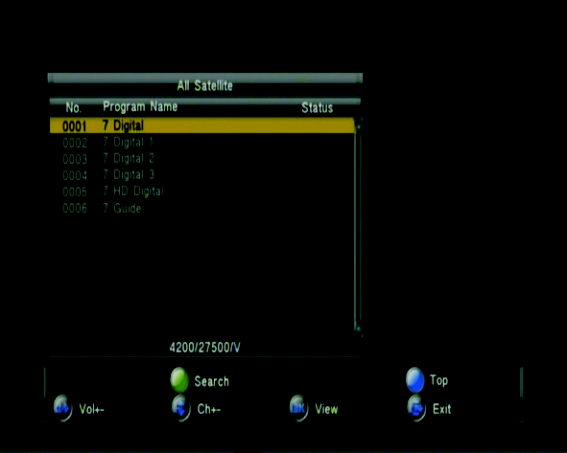

Notice:
(1)If your search completes successfully, the channel you search for will be highlighted and start playing in the screen window. If your search fails, the highlight will stay on the current channel playing in the screen window.
(2)The search scope is restricted to the current service group, not the entire channel list. If the channel you are searching for does not exist in the current channel list, the search would fail.
(3)When there is a recording in progress, OK list will only list the channels in the current TP, and you can switch among channels in the TP.

Volume Adjust
You cannot only adjust the volume but also mute it. In the mute mode, any attempt to adjust the volume will cancel the mute.
1.Press < Vol- / Vol+ / Left/Right> to adjust the volume.
2.Press < Mute> to mute your system.

Pause
You can pause the playback, Press <Yellow/Pause> to pause the playback.

Notice:
In pause status, you can press any button to resume the playback.

Audio Language
In Normal Play mode, you can press <Audio> button to switch the audio language and sound mode (LR/LL/RR). If you set your language in Main Menu->Language
-> Audio Language, the language will become the default language for your channel.
1.Press <Audio> to bring out the Audio setup page.
2.Press <Up/ Down> button to set your language or sound mode.
3.Press <Exit> to close the setup page.
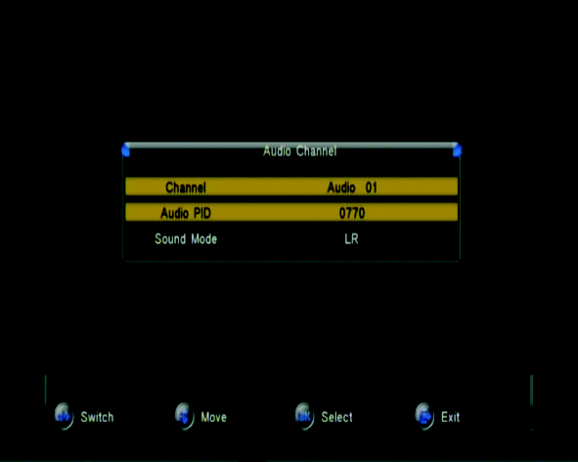

17

Notice:
(1) Any change in Audio Language setting will also trigger an appropriate change in
Audio PID field.
(2) The options for Sound Mode are LL, RR, and LR.

Switch among Your Favorites
In Normal Play mode, you can press <Fav Up/Down> button to switch among your favorite lists. For details about how to set your favorites.
1. Press < Favorite> to select your favorite list.
2. Press < CH+/CH-/Up/Down> to switch among the channels in the list.

Notice:
(1)You can get proper response when pressing < Favorite> only if there are some favorite lists already available; otherwise, you will get a Fav Off message.

(2)When switching to a favorite list, the first channel in the list will start playing.

Channel Status
This function provides you information about the status for the current channel
1.No Signal:
When the set-top box receives no signal, a no-signal message will appear.
2.No Service
When there is no program available from the channel or database, a no-service message will appear
2.Scrambled Service
You cannot watch a scrambled channel without paying for it. How to get the service, please contact your service provider.
4. Channel Lock
You have to enter the correct password to watch a channel whose Channel Lock is set to ON.

18

Multimedia

Movie
Movie Thumbnail/ Folder
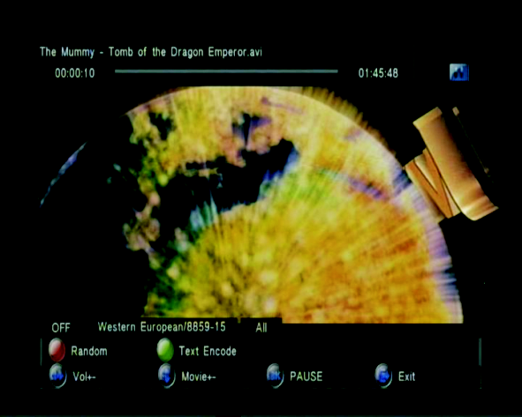
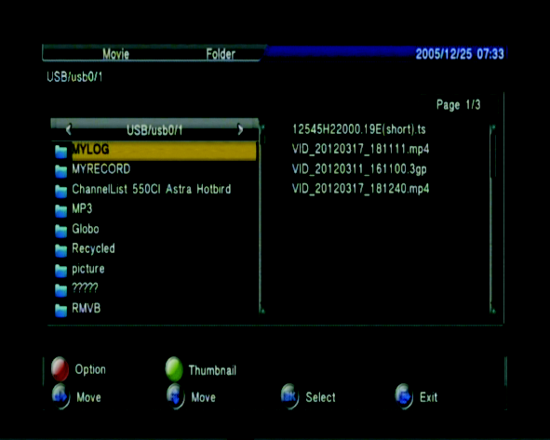

In Main menu, select Multimedia > Movie, and press <OK>.
In the thumbnail page, the available button operations are as followed:
<Menu>: this allows you to go back to Main menu.
<Red>: enter Movie play option setting.
(1)Random: Random play movie order on /off
(2)Repeat: Repeat play movie order all / off/ one
(3)Text Encode: You can specify the coding for the add-on subtitle files.
<Green>: switch between Thumbnail and Folder
<Left/Right>: when the focus is not on the Function Bar, they are for you to select folders or files in the file system. And when the focus is on the

Function Bar, they are for you to switch among the sub-option available there.
<Up/Down>: when the focus is not on the Function Bar, they are for you to select folders or files in the file system.

Movie Play
In Movie thumbnail or file page, select a playable file, and then press <OK>. This will open the Movie Play page.
<Red>: ON/OFF Random play movie
<Green>: switch Text Encode
<Repeat>: switch repeat play option All/Off/One
<Left/Right>: with these buttons you can select the value for the option.
<Menu>: allows you to exit the movie play page and back to Main menu.
<Audio>: This function is for you to switch between audio channels. And will not be enabled unless the file currently in play is provided with audio channels.
If the file comes with only one audio channel, this function will be set to that channel and will not respond when you press on
<SUBTITLE>: With this function you can select your desired subtitle language if the file currently in play comes with subtitle files.
Notice:
(1)The available option will be OFF if your movie file comes with no subtitle.
(2)The subtitle will show garbled characters if you fail to set the corresponding text encode.

19

Music
Music Thumbnail/Folder
In Main menu, select Music from the MULTIMEDIA, and then press <OK> to enter into the music Folder mode In the thumbnail /Folder page, the available button operations are as followed:
<Menu>: this allows you to go back to Main menu.
<Red>: enter Music play option setting.
1. Random play Music order on /off
2. Repeat play Music order all /off/one
3. Info Option when music playing, display music info or lyrics.
4. Display when music playing, display Cover or EQ <Green>: switch between
Thumbnail and Folder.

Music Play
Music Play Page: In Music thumbnail page, when the focus is on the File item, a press on <OK> will open the Music play page.
<Red>: ON /OFF Random play movie.
<Green>: switch Display mode.
<Yellow>: switch Info Option mode.
<Repeat>: switch repeat play option All/Off/One.

Photo
Photo Thumbnail / Folder
<Menu>: this allows you to go back to Main menu.
<Red>: enter photo play option setting. Random: Random play photo order on /
off Repeat: Repeat play photo order on/ off
Interval Time: select display timer when switch photo
Effect: effect play photo on/off
<Green>: switch between Thumbnail and Folders

Photo Play
In t he photo thumbnail / folder page, move the focus to the File item and press
< OK>. This will open the photo play page.
<Left/right>: turn left/right the phot when play photo.
<Green>: Play music when play photo
<Yellow>: vol-
<Blue>: vol+

20

DVR

DVR Features

DVR provides following features:
1. Support one-path TS recording.
2. Support time-shift function.
3. Support program playback functions including pause, fast forward/backward
(2x, , 32x) , and slow forward/ backward (1/2, 1/4).

4. Support background recording in same TP.
5. Support radio program recording.
6. Provide functions to format external USB/SD/HD devices.
7. Support file formats: FAT32/NTFS.
8. Provide functions to record audio, video, teletext, subtitle, and so on.

Recoding
Manual Recording
In normal play mode,<Rec> start recording function.
Recorder Setting -> one Button Recording is ON: Start the recording immediately, Recorder Setting -> one Button Recording is OFF: Set the

Duration, and press
<OK> to start the recording. If it is Recoding, you can reset the recording duration
<Stop> stop recording function.

Notice:
(1)If the subtitle of the program is already turned on, the recorded time in the
upper-left corner will appear awhile and then change into a red circle indicating the recording is in progress, and you can bring recorded time out for a check by pressing any button.
(2)If the recording duration is reached, the recording will automatically stop, and the system will go back to Normal Play mode.

Reservation recording
You can plan a reservation recording by setting the date, time, and channel. When the time arrives, the system will automatically switch to the channel and start recording. There are two ways to make such reservation: EPG and Advance Ti mer.
1. Advance Timer: Please see 3.4.5 advance timer
2. EPG: After pressing <Yellow> in the EPG page, you can plan a reservation recording by setting the time and channel, as shown below:
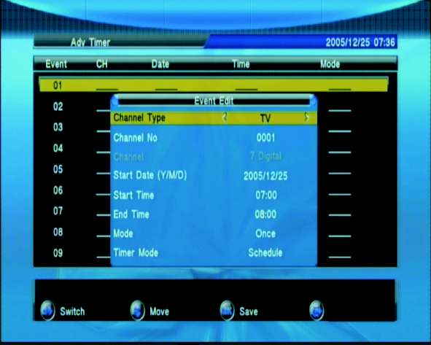
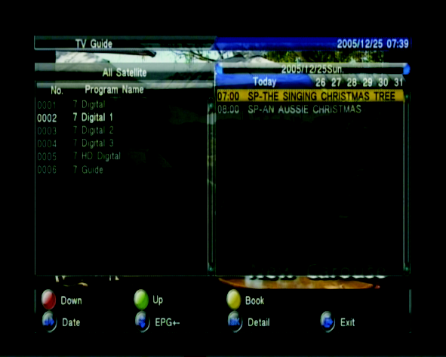

21

Timeshift
Timeshift feature
Multimedia -> Recorder Setting ->Timeshift ( Auto/Pause/Off).

Auto: the system automatically enters timeshift status when you go into Normal
Play mode.

Pause: While watching live program in Normal Play mode, you can pause the playback with <Pause> button. Then once you restore the playback by pressing
<Play> button, the system goes into the timeshift status. The stored time-shift data will be deleted after you exit from the timeshift status.

Off: During a recording in progress, you can enable the timeshift status only by pressing <Pause>.

Timeshift function
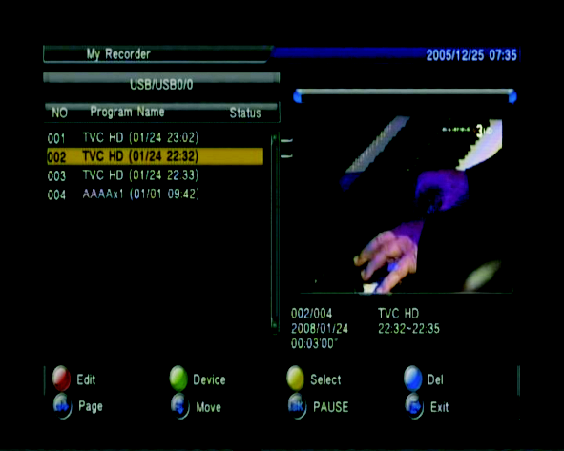
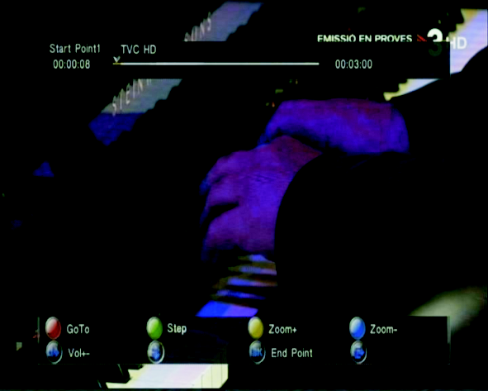

The time in the upper-left corner shows the recorded length.
The time in the lower left corner shows the time gap between the time frames of your playback and the live program.
The time in the lower right corner shows the available buffering length of the timeshift function.
The available buttons here are listed as below:

Button | Functions
FB button | Fast backward in X2/X4/X8/X16/X32 mode
Stop button | Stop the timeshift function
Play button | Start playing
FF button | Fast forward in X2/X4/X8/X16/X32 mode
Slow button | Slow forward in x1/2/x1/4 mode
Mute button | Mute the system

22

Record List Page
This page will list out all the available recorded files. The available buttons here are listed as below:

Button Functions
Red button | Rename a recorded file
Green button | Format an external device and set the device type, slot, and partition
Yellow button | Selected recorded file
Blue button | Del recorded file selected
Up/down/Left/right  button | Switch among the channels
Left/right button | When the focus in on the device type, you can switch among available device options.
OK button (Select ) | When the focus is on Function Bar >enable arrow key, this is used to confirm the selection with a check mark.
OK button | When the Function Bar is hidden, this is used as a play/pause button in the preview mode.
(Play /pause)  Play button | Start playing the selected file in full screen.

Press <OK> to activate the preview function, the selected file will be played in the small screen in the lower right corner.
The renamed file name will be saved once you exit the Edit function.
Recorded File Play
In Record list page, press on <Play> will start playing in full screen.
<Red> | Goto, you can playback the current file from the time frame you  specified, as shown below:  After you enter a valid time, your player will continue playing from the input time. However, if the time frame entered is not a valid one, the player will ignore it and keep playing.
<Green> | Step by setup play recorded file. You can exit the Step function and resume playing by pressing <Menu>
<Yellow> | Zoom+ If you switch to a next file in the zoom+ mode, you will automatically exit the zoom+ mode During the zoom-in mode you can scroll the image content with <Up/Down/Left/Right >.
<Blue> | Zoom- If you switch to the next file in the zoom- mode, you will automatically exit the zoom- mode.
<Vol+/-> | When in playback mode, you can press <Vol+/-> or <Left/Right>to adjust the volume.
<Info> | Open the Info page directly. Display playing recorded file information

23

IPTV Manual

The IP media player in the DJ-1997 is a simple unit that is both IP and MAC addressable.

You will find your IP and MAC addresses in the Multimedia Icon. Select “Network” and it will display your addresses and activate your wireless or wired connection. To set a wireless setting, you need to install the wireless antenna into the USB port on the back of the DJ-1997.

>Under the Network Interface, toggle to the right and select a wired or wireless format.
> Depress desired transmission be toggling between the two wired and wireless service. and > Hit “OK” button and the unit IP information is there along with additional information.

>Press “Menu” to exit from this menu.

>To activate the IPTV program list, just press the Yellow IPTV button on remote and the list will appear. We loaded some channels to view and test. When you want to access the list, just hit the “OK” button on the remote. To deactivate this list hit the “exit” key.

>Loading IP channels. Manhattan-Digital will be providing programming lists apps you can download to the DJ-1997. You can access in the future from our website at manhattan-digital.net
To load IP channels, we highly suggest that you perform this from your computer in the following matter.

1. IPTV list file edit:

Channel name, IPTV & URL Address Input.

Note:
>You must write comma (,) after channel name
> No space between channel name and comma & URL address

To load programming for a list generated by your computer. The IP download uses a simple text file from your computer. You can make a list from your computer and download into the DJ-1997 to watch from the DJ-1997 STB>

2. Update IPTV channel list
> Edit “iptvlist.txt” file in your PC according to above instruction
> Copy “iptvlist.txt” file to USB drive.
.>Insert USB drive to STB USB connector
> Go to IPTV menu
> Press “OK” button
> Press RED color button (EDIT)
>Press GREEN color button (IPTV CHANNEL URL USB SCAN)
>After USB is scanned a "Channels Found" message will appear. Press "OK" to confirm.

If you want stable IPTV channel connection, then we suggest that LAN (RJ45 cable) be connected directly to the receiver, as opposed to wireless setup.

24

Add IP channel manually:

>Hit Yellow IPTV button.
>Hit RED (Edit)

> Hit Yellow button “Add” to add the channel.

>Hit Edit again to enter name of channel with Keyboard.
Hit Edit to save name or "Confirm by pressing red button or OK on remote."

>Cursor down to Program URL. Hit Red (edit) Keyboard should pop-up. Enter URL address.

If at any time you make a mistake you need to cursor farthest to the upper right and Hit the Packman type key to delete characters.

>When finished, Hit the “OK” and exit out.

Delete IP Channels:

This is done in the same menu as the adding channels.

>In the menu you would hit the Blue Button and you can decide to delete a single channel or all of them. If you are loading IP channels from the USB stick, it is suggested to delete all and then add previous and new channels on the stick. This works the best.

NOTE: Channels can only be organized in list on computer. IPTV channels can't be moved by receiver when in IPTV edit mode.

EPG Setting:
Currently this function is not available with this unit. We will try and offer this as a later SW update.

Recording on IP:
Currently this function is not available. We will try and offer this on a later SW update.

>During some program watching you can hit the “OK” button and it will pause the program/movie. On the bottom you can also advance the play by hitting the “Go To” icon. A set of numbers will appear and depending the time you started at, you can advance the play to any minute and/or seconds setting that you desire. You can also go backwards if there is a portion of the program you want to re-watch at you desired location based in time. This list will give a time of the entire program you are watching.

>The menu will go away after 5 seconds, or after hitting the “Exit” key.
>To pause, hit “pause” button on top of remote. Hit > arrow play key to start program again.

This is a simple IPTV setup. We have more advanced units planned that will also include other medias as well.

We welcome your comments and suggestions to make this unit and future units better.

25

Troubleshooting

Problem | Potential Reasons | What to do
No picture | Power isn't connected | Connect the power
 | The power switch is not on | Switch on the power
Screen shows  No Signal | Not connect DVB-S cable | Plug in the DVB-S cable
 | Incorrect setting | Set up correct parameter
No sound from speaker | No or incorrect connection with audio cable | Connect the audio cable correctly
 | Mute the sound | Switch on the correct volume control
 | Incorrect sound track | Try another sound track
Only sound, no image on the screen | No or incorrect connection with AV cable | Connect the audio cable correctly
 | The program is a radio program | Press <TV/RADIO> key to shift into TV mode
 | In IPTV mode, Connection is not stable. | Exit all the way out of IPTV mode and re-enter IPTV mode
Remote control  unit is not workable | The battery is exhausted | Change new battery
 | Remote control unit is not in the right opposite of the front panel or too far from it | Adjust the way of holding remote control unit and near from the panel
 | Check for sunlight interference | No change needed. Although we need to know if there is going to be interference from other units. Meaning no inferred interference from other units. Tape across the sensor is best.
The image stop suddenly or mosaic | The signal is too weak | Strengthen the signal

26

Specifications

Item | Specification
Tuner | Frequency Range  Input Impedance | 950MHz to 2150MHz  75Ohms unbalanced
 | Signal Input Level | -65 ~ -25dBm
 | Symbol Rate | 2-45Mbps
 | LNB Power | 13/18V,Max 500mA
Demodulation | Demodulator | QPSK/8PSK
 | FEC | 1/2,2/3,3/4,5/6,7/8,8/9,9/10
Connections | LNB IN | F connector
 | LOOP OUT | F connector
 | Y/Pb/Pr | Connect to your TV component input terminals
 | SPDIF | SPDIF digital audio output
 | HDMI | Connects to HDMI in device.
 | RS232 | Used for data transport
 | USB | Connect to an external USB 2.0 device.
Power | Input | DC 12V
 | Consumption | Max 18W
Display | Decoder Module | PAL,NTSC
 | Resolution | 720X576(PAL),720X480(NTSC),  720P,1080i
Decoding | Aspect Ratio | 4:3(Letterbox, Pan& Scan)16:9
 | Video | MPEG2 Transport MP@ML.HL
 |  | MPEG4 AVC/H.264 HP@L4
 | Audio | MPEG2 Audio Layer I&II
Others | Compliance | ETSI/EN 300421 DVB-S compliant
 | Sound Mode | Right, Left, Stereo

*Specifications are subject to change without further notice

[Service]

Grandview Satellite
3859 East Grandview Ave.
Phoenix, AZ. 85032
TEL 602-363.1875

27

